Influence of Major Economic Events
Name:
Institutional Affiliation:
Course:
Lecturer Name:
Due Date:

In the United States, major economics events influence demand, supply and the economic equilibrium. The great recession, the housing bubble burst, oil embargo and the hurricane were defining macroeconomic events that translated into unprecedented effects in the economy. This essay assesses increased prices as an aftermath of the oil embargo and the Katrina Hurricane as well as high unemployment rate which was a combined effect of the Great Recession and the bubble burst.The great recession, house bubble burst, oil embargo and the hurricane were major economic event that led to rapid price increases and the dramatic drop in employment rate.
In 1973, the oil embargo in the United States led to the rapid price increases. During this time, OPEC had banned the exportation of oil to the United States. According to Amanda and Boyle (2019), the oil prices increased from $25.97 per barrel to $46.35 between 1973 and 1974. Progressively, hurricanes are amongst the most damaging natural disasters that depressed the financial markets and the stock markets. Murphy and Strobl (2009) indicate that the Katrina hurricane that occurred in 2005 caused a damage of about $80 billion dollars in Mississippi and Louisiana. Given that a considerable number of Americans live in the coastal areas, hurricanes cause a substantial damage causing increased house prices. The impact of hurricanes is reflected in the patterns of the aggregate economic growth. Thus, the oil embargo and hurricane translated into increased prices which is a major effect on the economy.
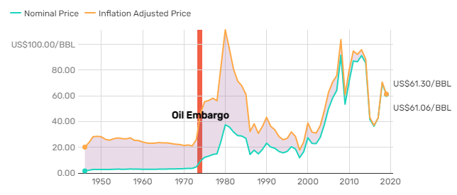Source: The Balance, 2019
Progressively, the 2006 these two events led to a combined impact on employment. The bubble burst led to a downturn in residential construction causing a financial crisis. According to Brayan (2013) there as an 11% decline during the great recession forcing the government to adopt expansionary monetary policy. The events revolving around the great recession in 2007 led to increased inefficiencies in the construction industry. During the period between 2006 and 2012, there was a loss of about $7 trillion in home equity and home mortgages lost value (Hasbini, 2017). Also, the housing bubble burst of about $8 trillion led to the collapse of financial markets making the home builders to be bankrupt. Several accounts indicate that the effects of the housing bubble burst and the great recession caused the longest and worst economic downturn. The rate of unemployment rose with about 10% in many parts of the country because individuals lost their investment on rental properties (Hasbini, 2017). Overall the housing bubble burst and the great recession caused a turmoil in the financial markets and regulations.
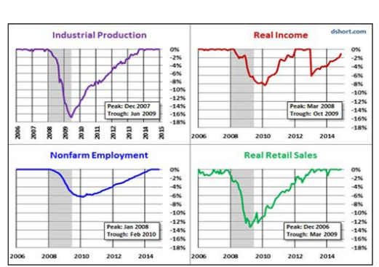
Source: Scholar Commons, 2017
Generally, major economic activities are responsible for the shifts in demand, supply and the economic equilibrium. Thus, the oil embargo and hurricanes are economic events that are associated with increased prices. Also, the housing bubble burst and the great recession lead to major changes in the financial markets. The events had a major impact on housing market and personal wealth. Economists argue that these occurrences greatly transformed the U.S economic activities.

References
Amadeo, K., & Boyle, M. (2019). OPEC Oil Embargo, Its Causes, and the Effects of the Crisis. The Balance. https://www.thebalance.com/opec-oil-embargo-causes-and-effects-of-the-crisis-3305806
Bryan, B. (2013). The great inflation. Federal Reserve History. https://www.federalreservehistory.org/essays/great-inflation

Hasbini, M. A. (2017). The Great Recession of 2007 and the Housing Market Crash: Why Did So Many Builders Fail?.
Murphy, A., & Strobl, E. (2009). The impact of hurricanes on housing prices: evidence from US coastal cities.

